Guildford Vision Group Calls for Rethink on North Street Development
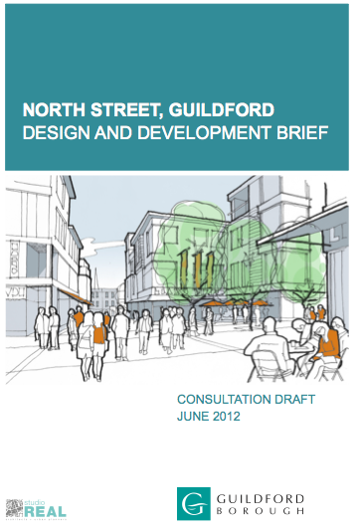Guildford Vision Group (GVG), is calling on Guildford Borough Council to withdraw what they claim is a ‘flawed’ Design and Development Brief for North Street.
The Leader of the Labour Group at Millmead, Cllr Angela Gunning, has commented that she was not even aware of the public consultation on the draft document. The consultation period ended last Friday.
Describing itself as a group ‘of concerned Guildford residents calling for a more visionary Master Plan for the town’, GVG has damned the draft Development Brief which, in a change from previous plans, includes proposals to extend the primary shopping area of the town up and behind North Street in the areas around Leapale and Commercial Roads.
GVG also claims that the brief warranted far more publicity, and a great deal more consultation and engagement than was undertaken.
A spokesman for the group said: “There is a widespread perception that the publication of supplementary planning documents is being used to deliver disguised outcomes favoured by the Council as landowner, to the disadvantage of other landowners and the wider community. Directing the foodstore requirement, for example, to an edge-of-centre site owned by the Council, and allocated for housing in the Local Plan, has reinforced that view.”
“Last year the Bellerby site was switched by a ‘supplementary planning document’ (SPD) from residential to retail development. GBC had previously obtained planning permission in 2007 to build 75 affordable homes on the Bellerby site in accordance with an earlier SPD it revoked last year.”
Following other comments of similar vein GVG believes traffic management is a key first step in any master plan for Guildford: “The North Street Brief has been drawn up without the benefit of any up to date traffic impact studies.”
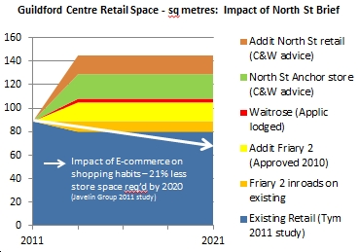
Graphic provided by GVG to illustrate impact of extra retail space in North Street
“It must be self-evident that an additional 60,000 sq m of retail space and the proposed Waitrose foodstore, on top of the existing 89,000 sq m, must have serious implications for the traffic and transport infrastructure.”
In late July Hermes, now the sole owner of the Friary Centre, made it known, through a letter sent by their consultants Terence O’Rourke Ltd to GBC, that they had concerns that the planning application for Waitrose could compromise overall plans for North Street redevelopment. They wrote that their concern: “…relates primarily to the potential of the transport impact…it is evident from the Waitrose planning application documents that the Council’s and Hermes commitment to major new retail development in the town centre has not been taken into account in the transport assessment.”
Chris Mansfield, head of economic development at GBC was reported in the Surrey Advertiser as saying that the two developments did not necessarily conflict. He was quoted as saying: “We are only dealing with one planning application at the moment and in order for it to be acceptable it must demonstrate how it will manage the impact it will have environmentally and for traffic.”
In addition to failing to recognise the primacy of the traffic problem GVG claims the following flaws in the draft brief:
- Poor timing. Consultation on the Brief closed just a few weeks before the Council is due to publish key, influential draft and final planning documents affecting the town centre including: the final Interim Town Centre Framework – due for adoption early September 2012; Draft Strategic Parking Strategy – due September 2012; Draft Local Plan Core Strategy – due Autumn 2012
- It makes no proposals for the location of a new bus station or for housing
- No consideration has been given to the substantial and prolonged impact on existing traders of the 65% increase in retail floorspace
- No allowance has been factored in for changes in shopping habits. Increased internet shopping and the prolonged poor economic situation will have an impact on existing retail space.
Members of the GBC Executive and Opposition groups were invited to comment on the GVG claims. Only one has been received.
Angela Gunning Leader of the Labour Group at GBC wrote: ‘I have not had the opportunity to see this document until now, so it comes as quite a surprise. I have no idea who were the attendees at the ‘stakeholder workshop’ held in May 2012 – but I can’t see much evidence of their ideas and concerns in this draft.
“There is a worrying preoccupation with the concept of an ‘anchor’ store, with little attention given to other aspects of urban living , namely housing - small planted areas – cafes – street art – water features - facilities for children. Very little attention also given to enabling significant improvements to traffic management.
“North Street was once the edge of the town, bounded by the town ditch (viz sewer), and then latterly a large cattle market which explains its unattractive camber and width. Not much attention in this brief is given to redesigning the street itself.
“I think there should be far greater public consultation – so that a far sighted vision for the heart of Guildford is integrated into the development of the rest of the centre. Guildford Vision are right to be critical of the draft. More work needs to be done, with wider and more comprehensive public input. I did not know that there had been a public consultation on this draft.”
Other comments and responses will be added if submitted.

